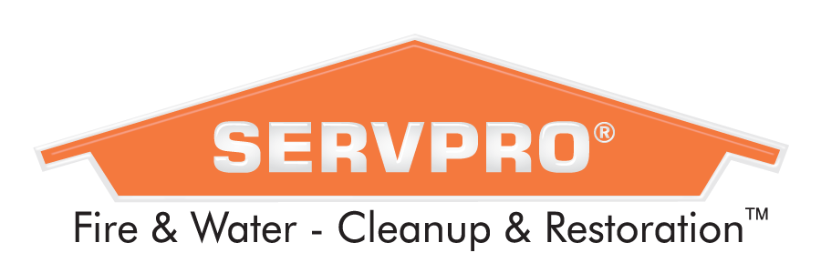

Project Manager

SERVPRO of Iowa City/Coralville, Ottumwa/Oskaloosa & Des Moines East/SW a cleaning & restoration Company specializing in water & fire mitigation, is currently hiring for a Project Manager.

General Job Summary
We are seeking someone who enjoys meeting new people, has excellent communication skills, and is a serious multi-tasker. As a valued employee, you will receive a competitive pay rate, with opportunity to learn and grow.

Essential Duties/Responsibilities
- Lead a team of technicians as they respond to and manage fire, water and mold losses
- Communicate with property owners and insurance adjusters
- Project estimating, job costing and quality control
- Create and/or review job scopes and ensure accuracy and clarity
- Ensure job processes and procedures are followed
- Network and build relationships with Centers of Influence
- Manage production staff as necessary
- Oversee or manage storm and large loss jobs
- Review all job paperwork (scope, estimate, job diary, and work orders) to ensure staff is ready to do the job efficiently and within compliance
Position Requirements
- Valid driver’s license with good driving record
- High school diploma/GED
- Advanced computer skills
- 3 years’ experience in fire and water restoration industry preferred
- Ability to pass a criminal history background check
- Effective written and oral communication
- Intermediate math skills
- IICRC certifications preferred
- Ability to lift a minimum of 50 pounds regularly, occasionally up to 100 pounds with assistance
- Ability to climb ladders, work at ceiling heights, work in tight spaces (i.e. crawls spaces, attics)
- Ability to sit/stand/walk for prolonged periods of time
- Ability to repetitively push/pull/lift/carry objects
- Ability to work with/around cleaning products/chemicals
- Ability to travel locally and out of state when necessary
Job Type: Full-time, 7:45am – 5pm, Monday – Friday with a rotating on call status
Required license or certification
- Iowa Driver's License
SERVPRO specializes in the cleanup and restoration of residential and commercial property after a fire, smoke, or water damage situation. So, when disaster strikes, homeowners, businesses and insurance providers will rely on us to respond with unparalleled service excellence. As a nation's leading fire and water cleanup and restoration company with more than 1,700 Franchises nationwide, we are growing
rapidly, creating exciting opportunities for "A Level" talent.

We are also an accredited member of the Better Business Bureau. We are an Equal Opportunity Employer. This company does not and will not discriminate in employment and personnel practices on the basis of race, color, religion, sex, disability, age, national origin, veteran status or any other characteristic protected by law.

Recruiter Contact:
Andrea Meyer: andrea@servpro.me
Phone: 319-338-8550
Career Website: https://servpro.careerplug.com/account

